Supplement 3:
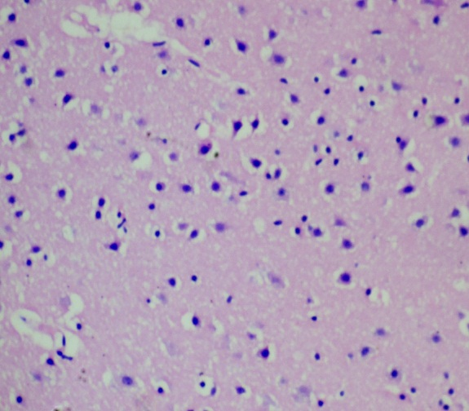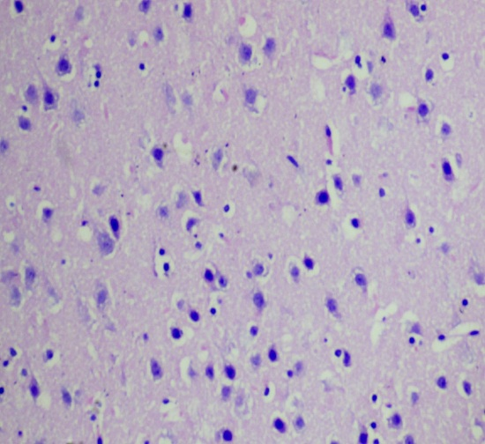
Gc
Pc
Ng
Pc
Gc
Ng
B
A
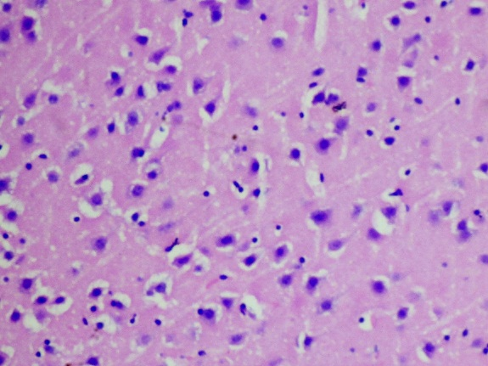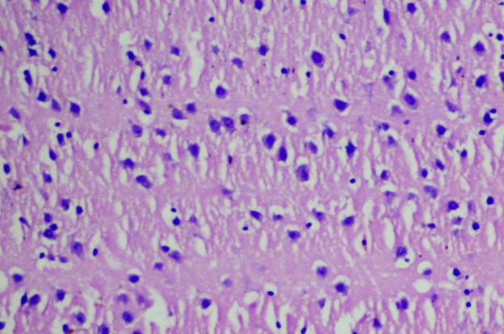
Gc
Gc
Pc
Ng
Ng
Pc
C
D
Figure 1: Photomicrographs of the mouse cerebral cortex section showing granule cells (Gc), pyramidal cells (Pc) and neuroglia (Ng) following 28-day treatment with (a) distilled water (b) 95 mg/kg (c) 190 mg/kg and (d) 380 mg/kg of aqueous fruit extract of S. incanumLinn. HaE stain x 160.

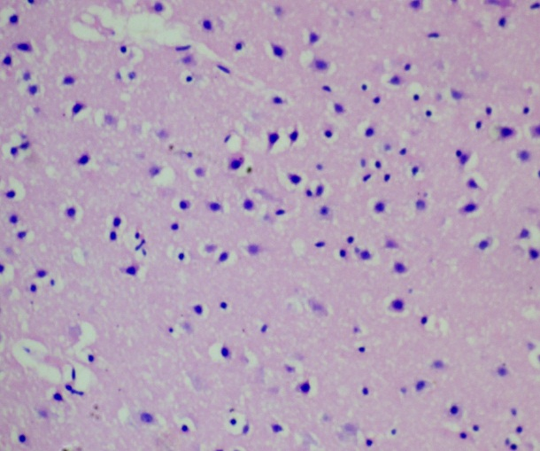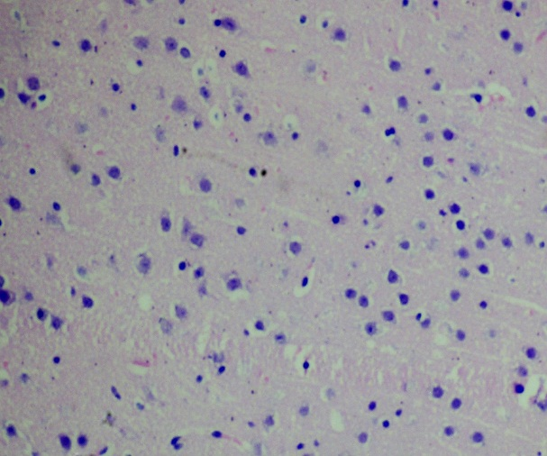
Pc
Pc
Gc
Ng
Ng
Gc
B
A

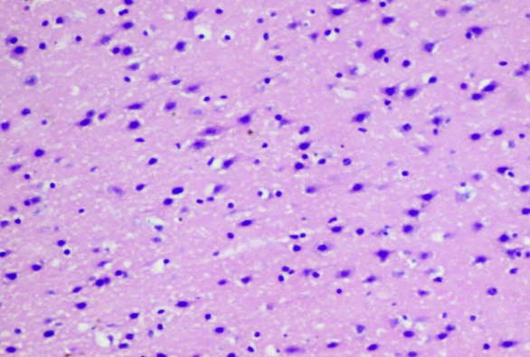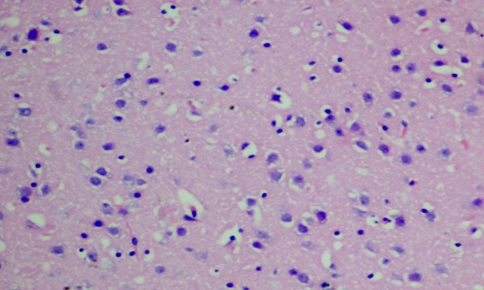
Gc
Pc
Gc
Ng
Ng
Pc
C
D
Figure 2: Photomicrographs of the mouse cerebral cortex sections showing granule cells (Gc), pyramidal cells (Pc) and neuroglia (Ng) following 28-day treatment with (a) distilled water (b) 125 mg/kg (c) 250 mg/kg and (d) 500 mg/kg of ethanol fruit extract of S. incanumLinn. HaE stain x 160.

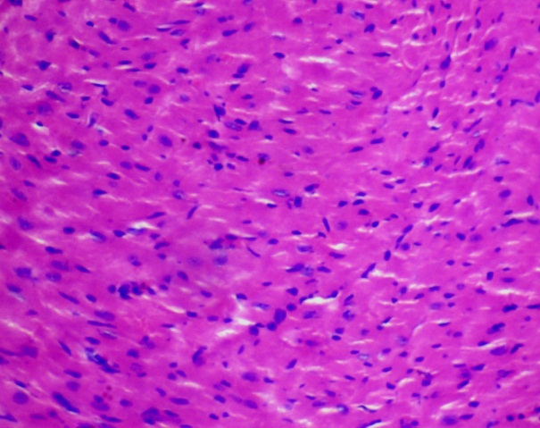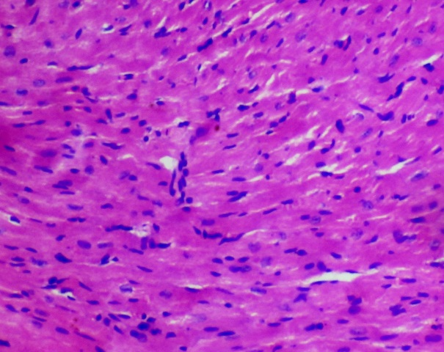
A
B
N
MF
N
MF

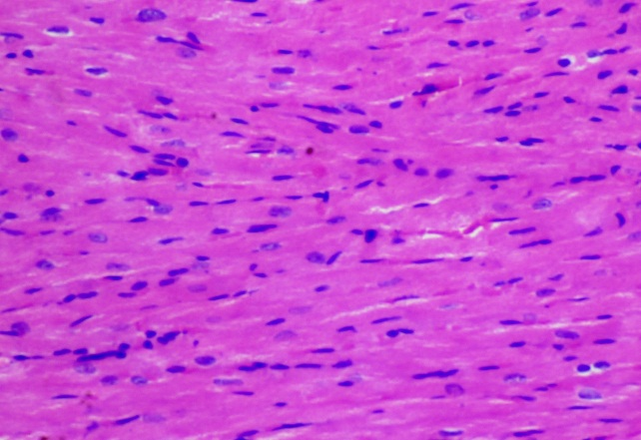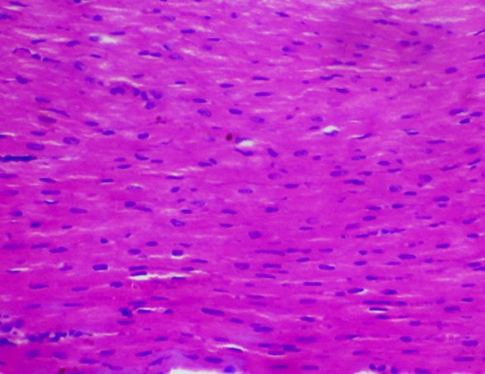
MF
N
C
MF
N
D
Figure 3: Photomicrographs of the mouse cardiac tissue sections showing nuclei of cardiomyocytes (N) and myofibres (MF) following 28-day treatment with (a) distilled water (b) 95 mg/kg (c) 190 mg/kg and (d) 380 mg/kg of aqueous fruit extract of S. incanumLinn. HaE stain x 160.

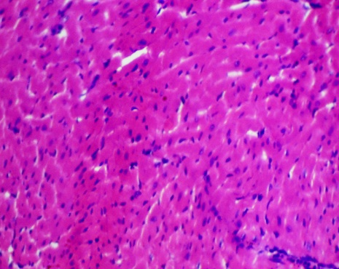
N
MF
MF
N
A
B

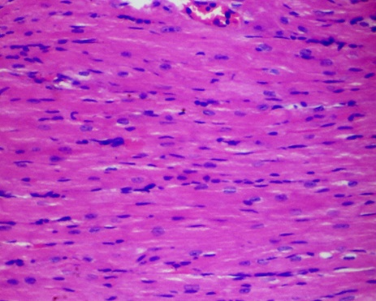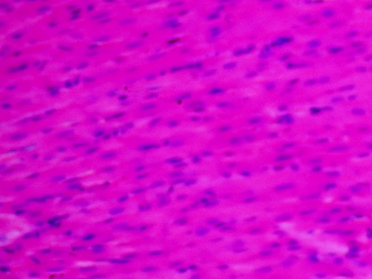
MF
N
MF
N
C
D
Figure 4: Photomicrographs of the mouse cardiac tissue sections showing nuclei of cardiomyocytes (N) and myofibres (MF) following 28-day treatment with (a) distilled water (b) 125 mg/kg (c) 250 mg/kg and (d) 500 mg/kg of ethanol fruit extract of S. incanumLinn. HaE stain x 160.

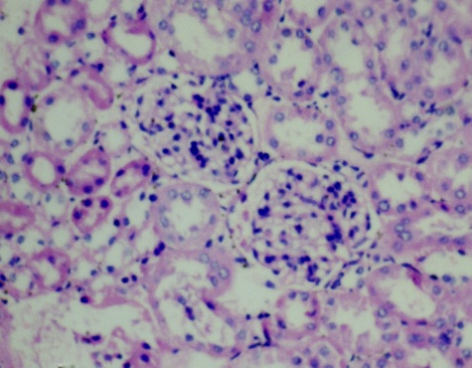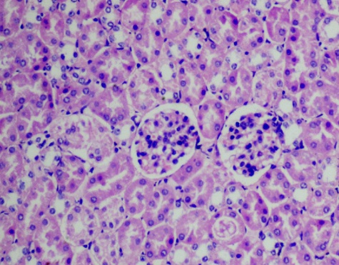
DT
PT
BC
BS
G
PT
BS
BC
G
DT
B
A

Figure5: Photomicrographs of the mouse kidney tissue sections showing glomerulus (G), Bowman’s capsule (BC), Bowman’s space (BS), Proximal tubule (PT) and distal tubule (DT) following 28-day treatment with (a) distilled water and (b) 95 mg/kg of aqueous fruit extract of S. incanumLinn. HaE stain x 160.

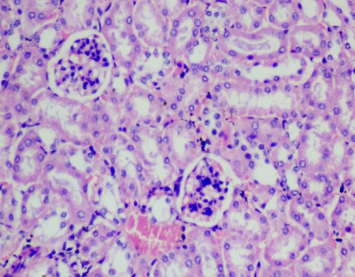
G
PT
BC
BS
DT
B
BS
BC
G
A
DT
PT

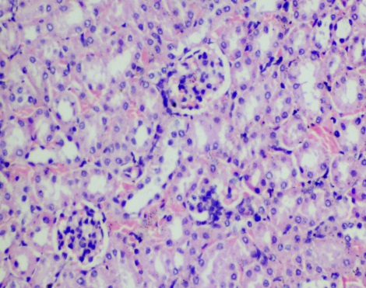
C
DT
PT
G
BS
BC
Figure6: Photomicrographs of the mouse kidney tissue sections showing glomerulus (G), Bowman’s capsule (BC), Bowman’s space (BS), Proximal tubule (PT) and distal tubule (DT) following 28-day treatment with (a) distilled water (b) 125 mg/kg and (c) 250 mg/kg of ethanol fruit extract of S. incanumLinn. HaE stain x 160.

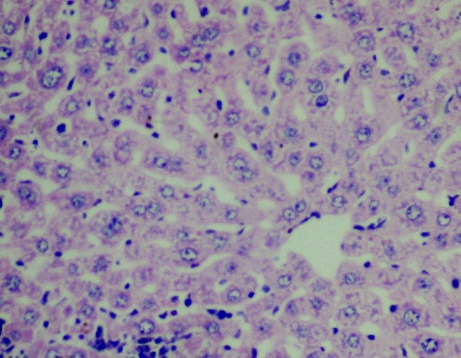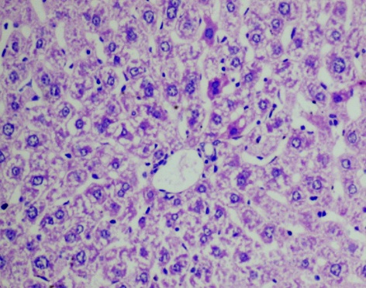
V
H
H
Hn
S
S
Hn
V
CV
CV
A
B
K

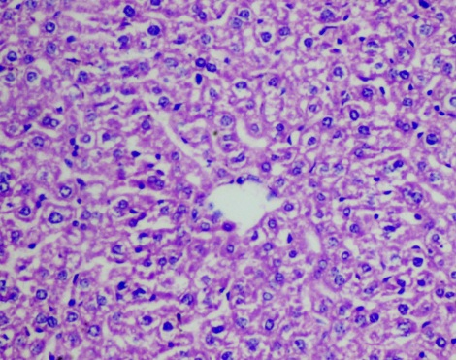
Hn
S
H
K
CV
C
Figure 7: Photomicrographs of the mouse liver tissue sections showing sinusoidal spaces (S), demarcating hepatocytes (H), hepatocyte nucleus (Hn), Kupffer cell nucleus (K), Central vein (CV) and vacuoles (V) following 28-day treatment with (a) distilled water (b) 95 mg/kg and(c) 190 mg/kg of aqueous fruit extract of S. incanumLinn. HaE stain x 160.

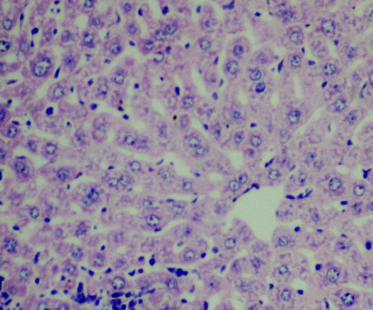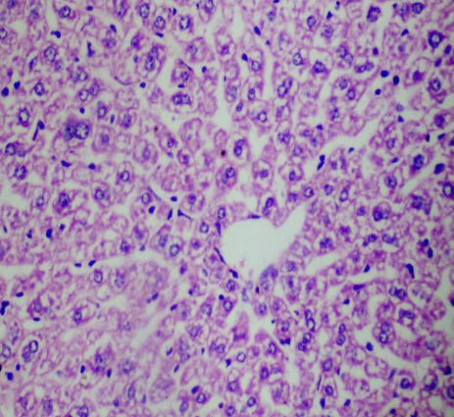
H
Hn
V
S
K
B
A
K
H
Hn
S
CV
CV
CV

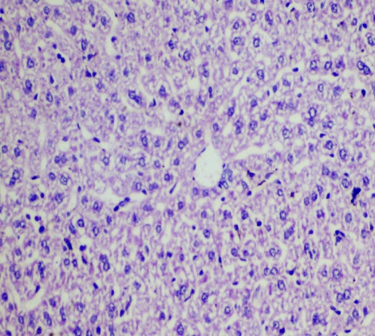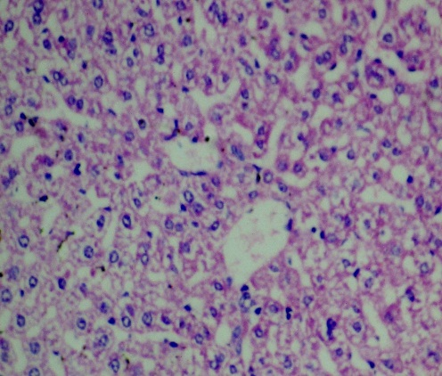
D
C
K
K
H
Hn
S
CV
H
Hn
S
V
Figure 8: Photomicrographs of the mouse liver tissue sections showing sinusoidal spaces (S), demarcating hepatocytes (H), hepatocyte nucleus (Hn), Kupffer cell nucleus (K), Central vein (CV) and vacuoles (V) following 28-day treatment with (a) distilled water (b) 125 mg/kg (c) 250 mg/kg and (d) 500 mg/kg of ethanol fruit extract of S. incanumLinn. HaE stain x 160.

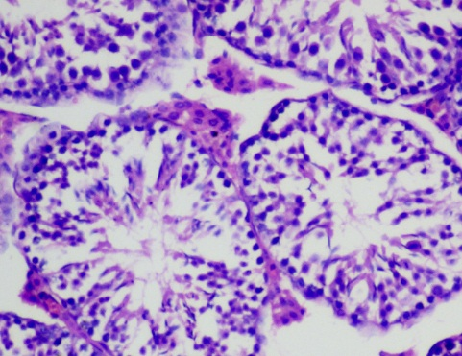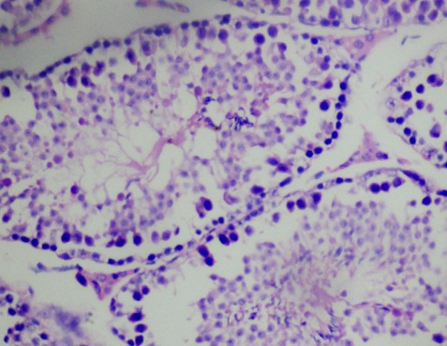
St
Sd
Sp
V
It
Sd
Sp
L
B
A
It
L

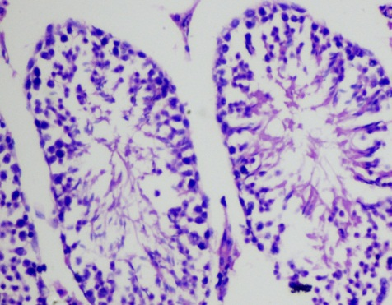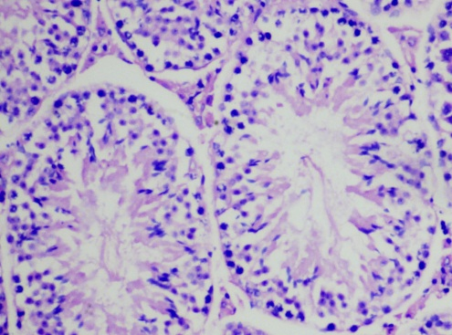
St
Sd
St
Sp
Sd
Sp
It
L
It
L
C
D

Figure 9: Photomicrographs of the mouse testis tissue sections showing interstitial connective tissue (It), seminiferous tubules (St), spermatids (Sd), spermatozoa (SP) and vacuoles (V) following 28-day treatment with (a) distilled water (b) 95 mg/kg (c) 190 mg/kg and (d) 380 mg/kg of aqueous fruit extract of S. incanumLinn. HaE stain x 160.

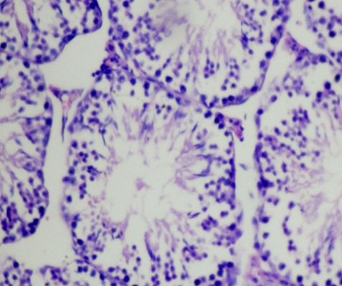
It
B
A
St
Sp
Sd
L
Sp
L
Sd
It
Sd

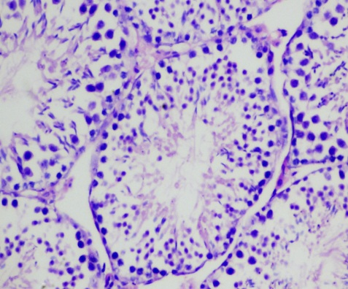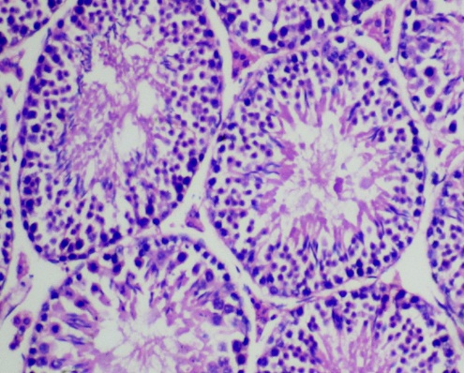
D
C
V
St
It
Sp
St
It
Sd
Sp
L
Figure 10: Photomicrographs of the mouse testis tissue sections showing interstitial connective tissue (It), seminiferous tubules (St), spermatids (Sd), spermatozoa (SP) and vacuoles (V) following 28-day treatment with (a) distilled water (b) 125 mg/kg (c) 250 mg/kg and (d) 500 mg/kg of ethanol fruit extract of S. incanumLinn. HaE stain x 160.

