Appendix A: Color Calculations

As mentioned before, the spectral optimized average values of μ_{sca} and μ_{abs} have been carried out from a set of 33 solutions. Each one of these solutions were also obtained from 33 solutions previously calculated. Besides average values, standard deviations were calculated, σ_{sca} and σ_{abs}. The following figures display the averages values contained in a colored stripe whose borders are determined by the spectral behavior of μ_{sca}-σ_{sca} and μ_{sca}+σ_{sca}, μ_{abs}-σ_{abs} and μ_{abs}+σ_{abs}, respectively. As seen, the largest deviations are displayed in the spectral regions where the transmittance values are close to zero due to absorption and scattering by chlorophyll a pigmented grains. A luminance bar has been displayed at the right side of each figure, with a circle or half circle whose position corresponds to the RGB values indicated in the horizontal bar at the top of each figure. The luminance bar allows to have a visual perception of what the color would look like, in light transmission mode, under decreasing lighting conditions. The RGB values have been obtained from the chromaticity coordinates (x,y,z), the transmittance spectra, the solar spectral irradiance AM1.5 [44], and the CIE color-matching functions [45,46]. The variation of RGB values with pigment concentration, as displayed in Figure A5, indicates that the blue color is practically suppressed from the directional transmitted light when increasing the volume fraction. This happens predominantly due to scattering at short wavelengths, with an additional contribution by absorption. The green hue is more perceptible with increasing pigment concentration because the absorption of red light increases as the volume fraction of pigments also increases, decreasing the amount of red light contributing to the effective color of the samples.
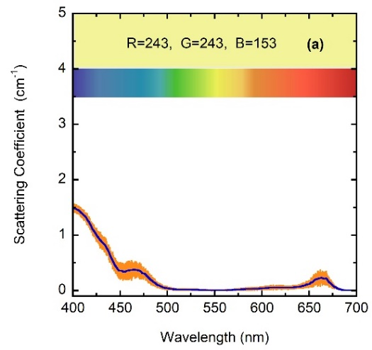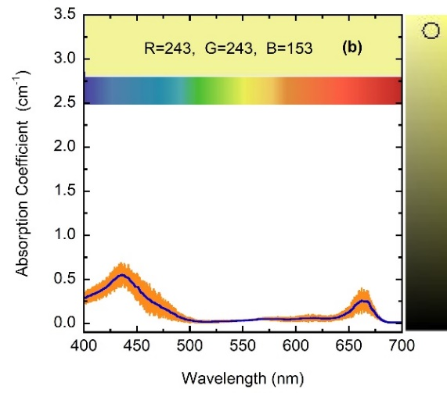

Figure A1. Variations of the average μ_{sca} and μ_{abs} coefficients per unit length (a&b) for the sample with the lowest concentration: f=F/8 (solid lines). Colored strip borders are determined by the corresponding standard deviations

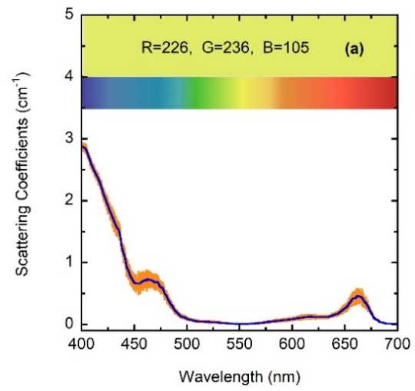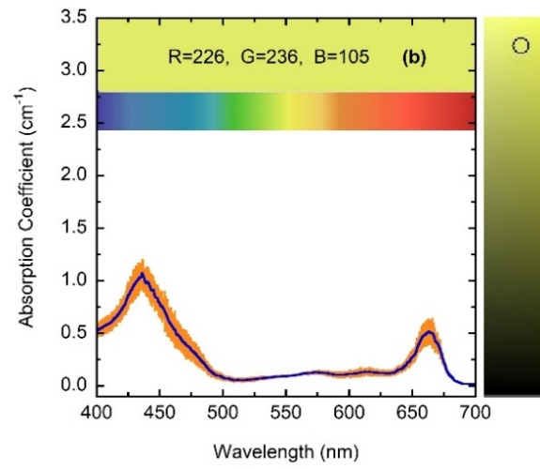

Figure A2. Spectral variations of the average μ_{sca} and μ_{abs} coefficients per unit length (a&b) for the sample with the concentration f=F/4 (solid lines). Colored strip borders are determined by the corresponding standard deviations.

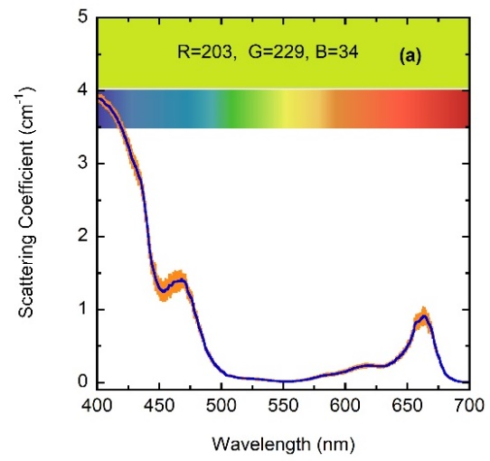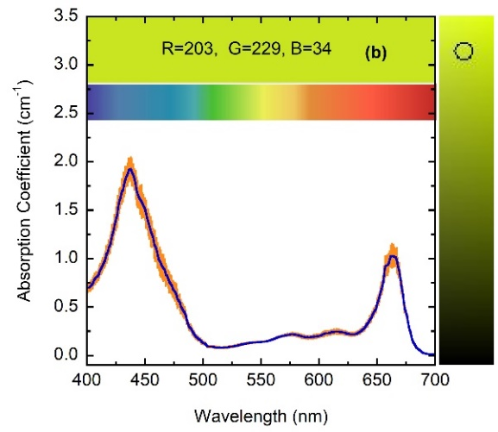

Figure A3. Spectral variations of the average μ_{sca} and μ_{abs} coefficients per unit length (a&b) for the sample with the concentration f=F/2 (solid lines). Colored strip borders are determined by the corresponding standard deviations.

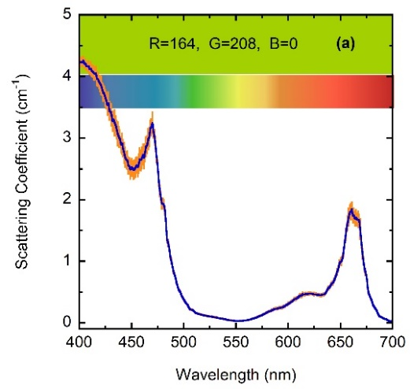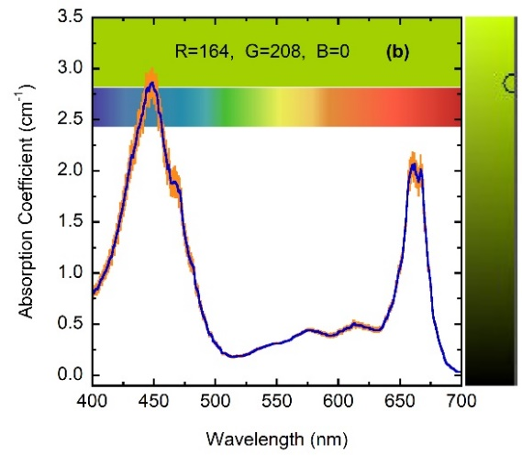

Figure A4. Spectral variations of the average μ_{sca} and μ_{abs} coefficients per unit length (a&b) for the sample with the largest concentration: f=F (solid lines). Colored strip borders are determined by the corresponding standard deviations. The luminance bar is displayed at the right side of the figure.
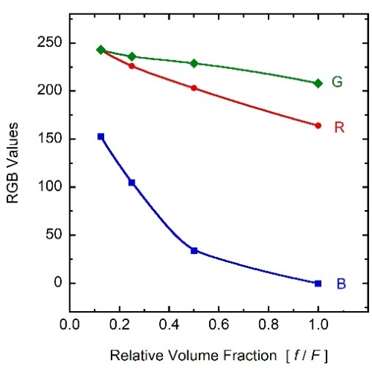

Figure A5. Variation of the RGB values with relative concentration of the chlorophyll a pigmented grains in the four samples considered.

