Table 22: Freundlich parameters for pyrethroids and mirex in soil sample studied (organic content 2.1%). Note: λ- cyhalothrin was also studied in this paper, see above structure.
Pyrethroid and Standard | Slope, 1/n | n | k
Cyfluthrin | 1.1014 | 0.906 | 1.021
λ-cyhalothrin | 1.1000 | 0.909 | 7.603
Cypermethrin | 0.9965 | 1.004 | 5.233
Deltamethrin | 1.1000 | 0.909 | 2.443
Fenvalerate | 0.9561 | 1.046 | 13.105
Permethrin | 0.9927 | 1.007 | 1.874
Mirex, Standard | 1.1018 | 0.907 | 12.705
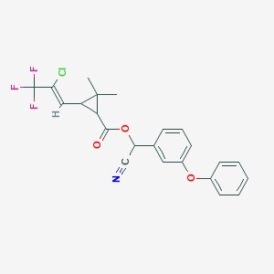
Figure is referred to in the legend to Table 22.
RSD ± 2.5 - 4.6, n = 3.

